Instructions
- Print out the included templates on white paper.
- Use crayons or markers to color the toilet paper roll animals the way you like.
- Cut out each piece and assemble as shown below.
- You're done with your toilet paper roll animals!
- UNICORN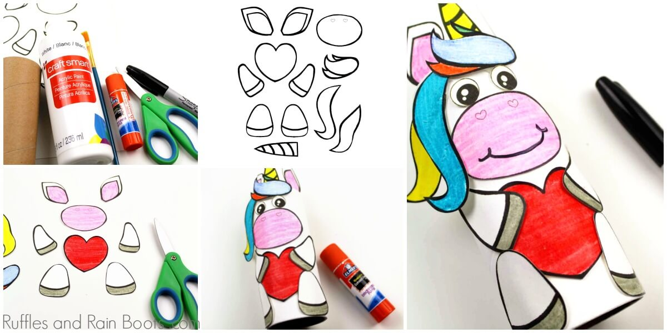
- HIPPO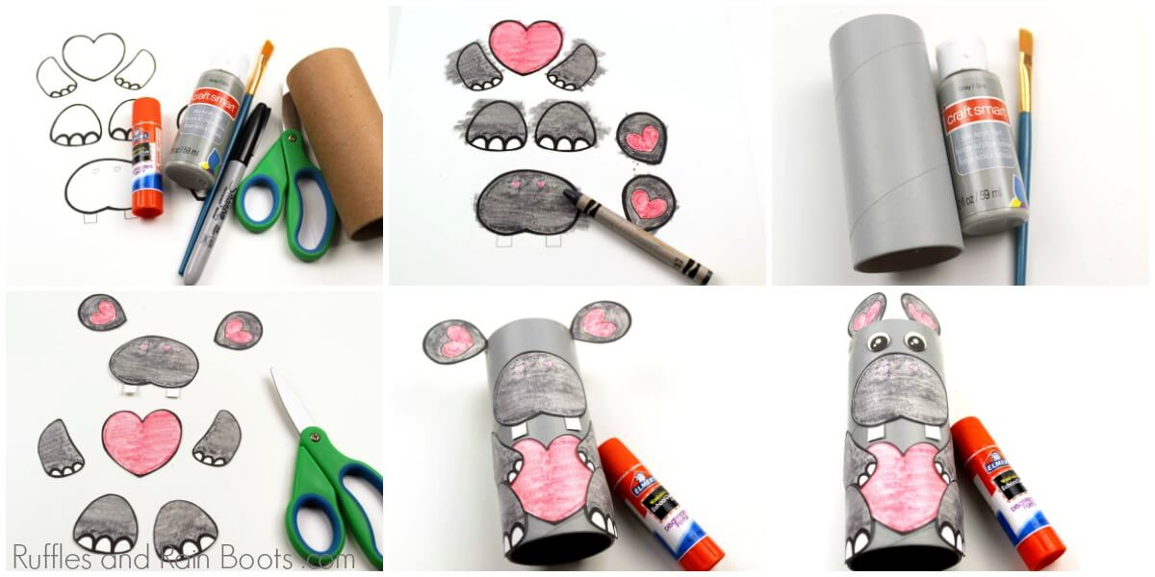
- MOOSE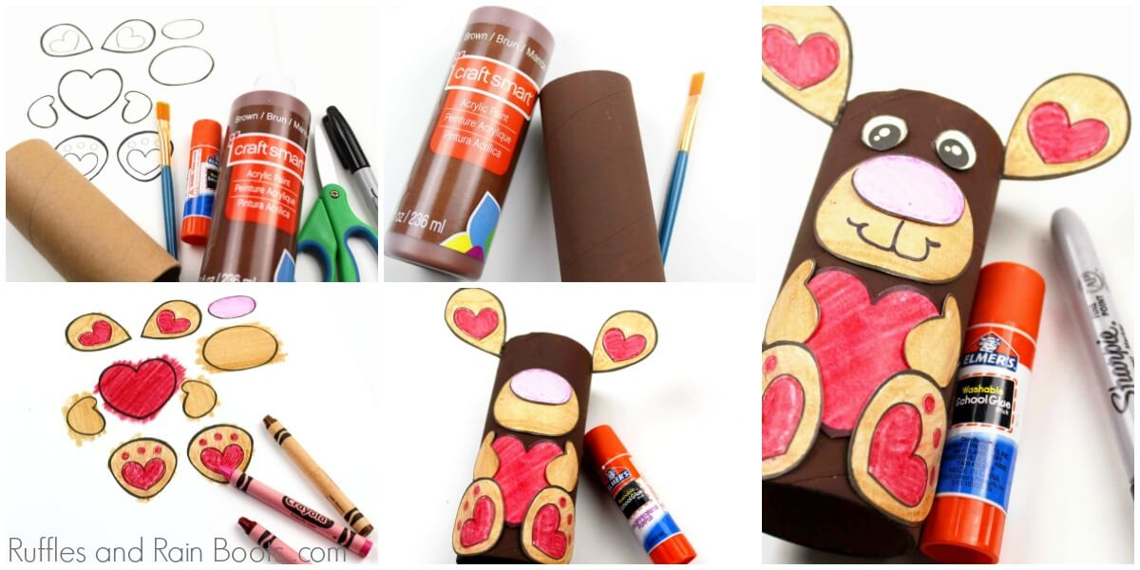
- PENGUIN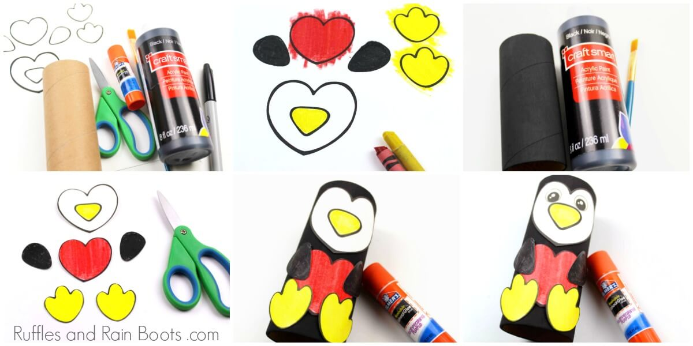
- MONKEY